**Practical No: 2**

* Load mongoDb from mongodb.com. click on try for free/download from top. Select server click on download.
* Click next to installation. Accept the condition. click on complete.
* Create a folder in C🡪program files🡪MongoDb🡪server🡪4.0🡪data🡪create db folder.
* Copy path C🡪program files🡪MongoDb🡪server🡪4.0🡪bin

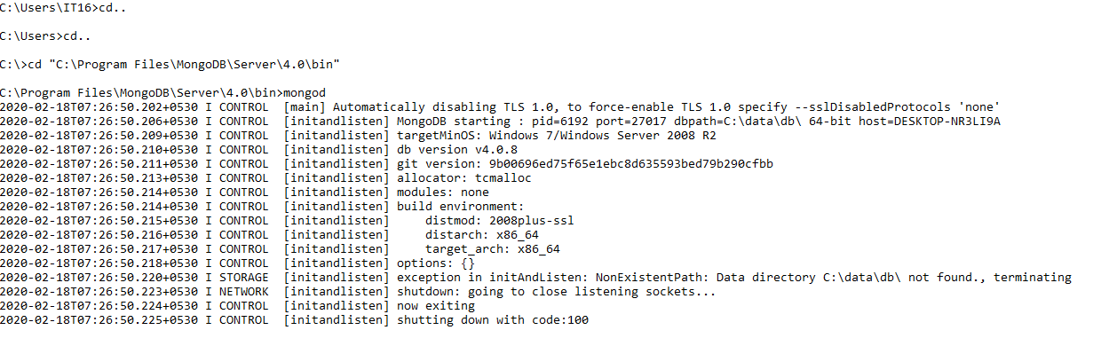

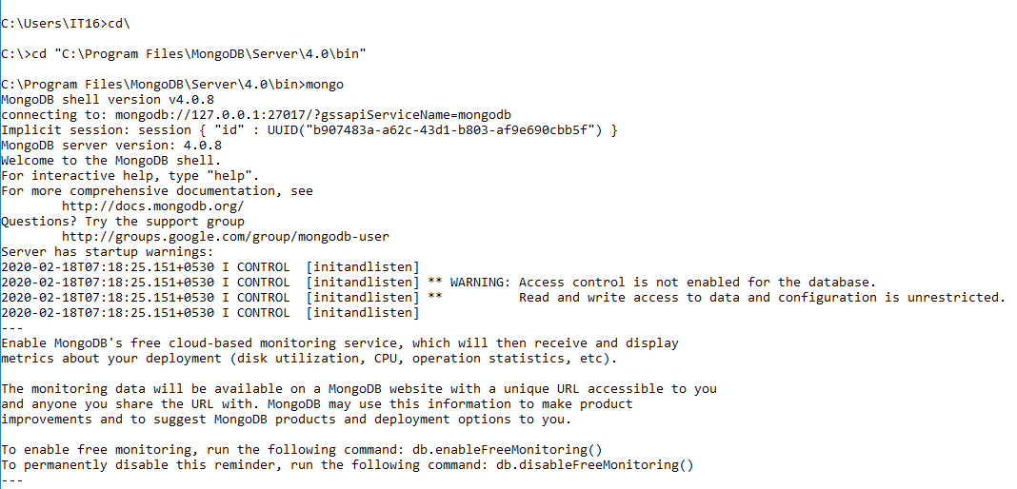

**To display the name of current database.**



**To display list of databases present.**

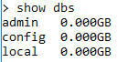

**To create new database**



**To insert data in database**



**After inserting data the database is visible.**

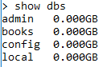

**To check collections created.**



**Creating collection with option before inserting the data.(it creates an empty collection.)**

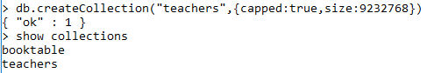

**To drop a collection.**

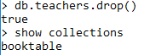

**To insert multiple data**

**Queries**

**find(): displays all the data in collection**.



**pretty(): for displaying the data in a format.**

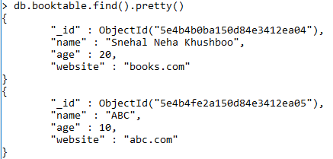

**Equality criteria:**

**To fetch data with name=”Snehal Neha Khushboo ” from booktable collection.**

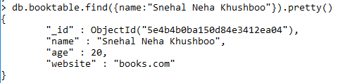

**Greater than criteria:**

**To fetch data with age=$gt 19 from booktable collection.**

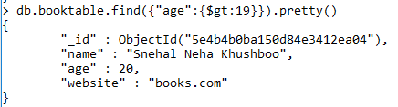

**Less than criteria:**

**To fetch data with age=$lt 19 from booktable collection.**

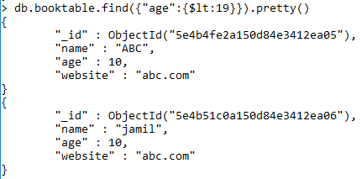

**Not Equals criteria(ne):**

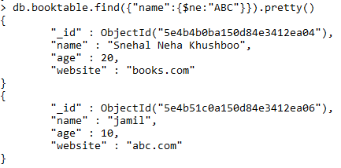

**Update command:**

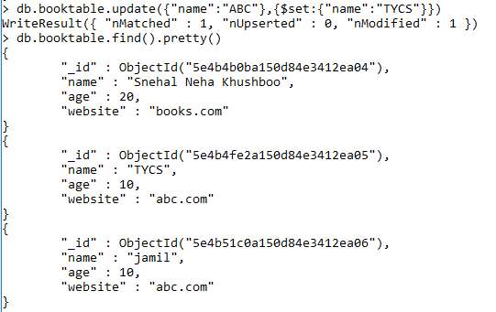

**Remove command: To remove collection.**

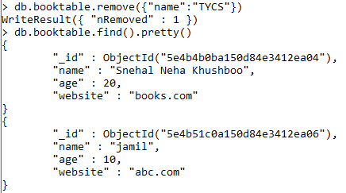

**Mongodb projection:**

**To display only the name**

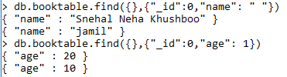

**limit() method.**

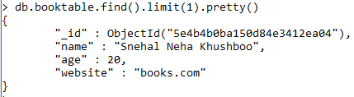

**skip() method**

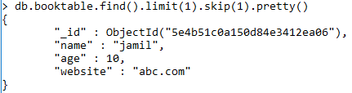

**sort() method**



